**Hillview Nursery School Home Learning**

**Dear Parents,**

**Its important that you spend some time enjoying some of these activities with your child. It will reinforce the learning that is taking place at nursery and offer a variety of opportunities to enable you as parents to engage in your child’s learning journey.**

**Focus books we are reading this term:**

Whatever next by Jill Murphy

The Gruffalo by Julia Donaldson

Nursery Rhymes

Visit the library and visit regularly.

**Reading**

**READ WITH YOUR CHILD EVERYDAY**

**Literacy**

* Singing songs with actions:

If your happy and you know it

The wheels on the bus

Miss Polly

Zoom zoom zoom

Head, shoulders, knees, and toes

* Use musical instruments or clap along to the beat and rhythm of the music.
* Draw a Christmas picture for Father Christmas (He will be visiting on Thursday 14th December
* Write a letter to Santa and post it in

the letter box.



**Mathematics**

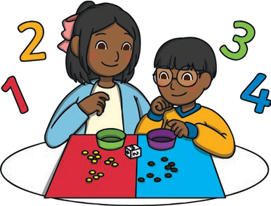

* Sing number songs ie 1,2,3,4,5 once I caught a fish alive, 5 current buns.
* Identify numbers at home and in the environment ie laying the table; how many forks do we need, how many red cars, how many trees on the street.
* Practice numbers in sequence – line up some lego / fruit pieces / cars and count in order as you point.
* Play a game with a dice – can you say how many dots are on each side without counting them?

**Communication and Language development**

* Sing and dance.
* Read stories and rhymes together every day.
* Ask who, what, where and when questions to encourage more complex answers and to ignite their imagination eg
* Who could that be?
* What do you think might happen next?
* Where do you think that came from?
* When shall we do that?
* Talk about what you are doing whilst you do it.

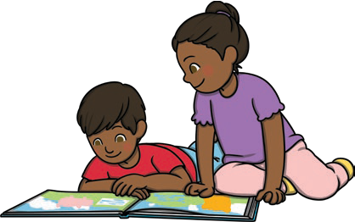

**Personal, Social and Emotional development**

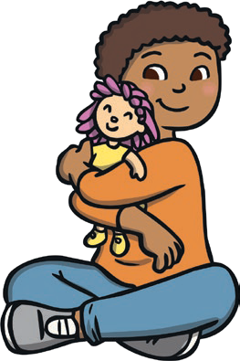

* Go to the park give opportunity for your child to play with or alongside other children.
* Help your child to understand emotions. Talk to them about how they feel. What makes you feel happy? sad? etc
* Give lots of praise to your child.
* Talk to your child about their keyperson – read through their ‘All about me’ form.
* Talk about the importance of being kind, sharing and caring for others.

**Understanding the World**

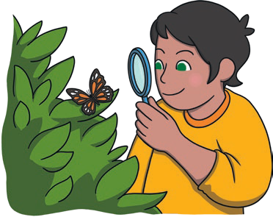

* Read stories about different people from around the world.
* Talk about different occupations and roles ie
* Doctor, shop keeper, bus driver, chef etc
* Talk about friends at nursery.
* Go for a walk and explore nature – collect some autumn treasures – pinecones, conkers, leaves – go home and talk about what you found.
* Take photographs of the environment and talk about where we live.
* Talk about the weather
* **Physical Development**

Fine motor skills –

* Make playdough together and make different shapes and explore.
* Cutting catalogues with scissors
* Cut own fruit at snack time (with supervision)
* Draw autumn / winter / Christmas pictures using pencils, chalk, and crayons.

Gross motor skills –

* Visit the park and climb.
* Run races.
* Play hide and seek.
* Dance to the music
* Kick / roll the ball to each other.

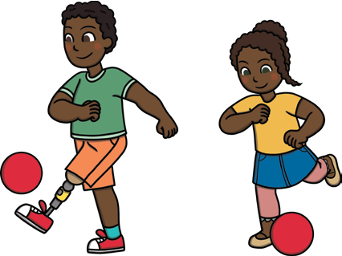

**Expressive art and design**

* Dance with whole body to different types of music.
* Role play / pretend play activities – pretend to be a teacher or doctor.
* Use various tools to create a Christmas or winter picture – paint, sticking, printing, drawing and decorate using fabrics, different materials and milk bottle lids.
* Talk about shapes in the environment.



**Please take some photographs of your child doing these activities and send them to us via EYLOG.**

**Have fun!**