**Hillview Nursery School Home Learning**

**Dear Parents,**

**Its important that you spend some time enjoying some of these activities with your child. It will reinforce the learning that is taking place at nursery and offer a variety of opportunities to enable you as parents to engage in your child’s learning journey.**

**Focus books we are reading this term:**

Traditional Tales ie -

Three Little Pigs

Goldilocks and the Three Bears

Little Red Riding Hood

Visit the library and visit regularly.

**Reading**

**READ WITH YOUR CHILD EVERYDAY**

**Literacy**

* Singing songs and rhymes with actions.
* Talk about the pictures in a book – What could have happened? Tell s different story using the pictures.
* Write a letter / Draw a picture for the big bad wolf.
* Draw pictures and ask them to talk about what they have drawn.
* Put sand / rice on a tray and draw or write in it.
* Write a shopping list together – child can draw the item or write the item.

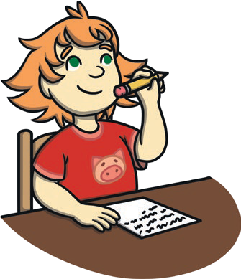

**Mathematics**

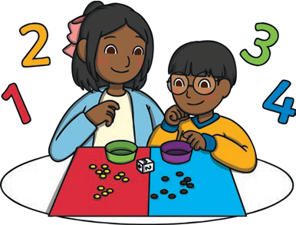

* Sing number songs.
* Use blocks ie lego or bricks to create structures
* Identify numbers in the environment – door numbers / bus numbers.
* Talk about past events ie when child was a baby, a holiday, a visit.
* Match numerals to quantity is write the number 2 and draw or add 2 apples.
* Identify numbers 1 – 5 and beyond if appropriate.
* Bake biscuits for red riding hoods granny – Measure ingredients.

**Communication and Language development**

* Sing and dance.
* Read stories and rhymes together every day.
* Ask who, what, where and when questions to encourage more complex answers and to ignite their imagination eg
* Who could that be?
* What do you think might happen next?
* Where do you think that came from?
* When shall we do that?
* Introduce new words to vocabulary.
* Give simple or complex instructions for child to listen to and follow. 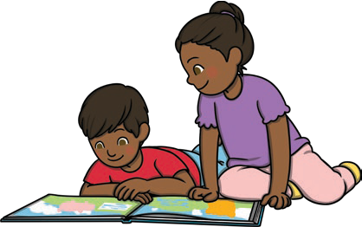

**Personal, Social and Emotional development**

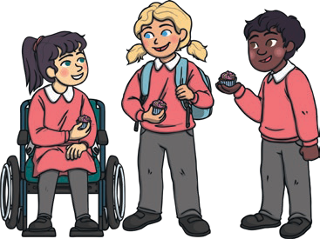

* Give opportunity for your child to play with or alongside other children.
* Support your child in making decisions / choices.
* Give lots of praise to your child.
* Talk about the importance of being kind, sharing and caring for others.
* Talk about similarities and differences between your child and others ie hair colour, eye colour, interests etc
* Talk about feelings and emotions, help your child to express how they are feeling.

**Understanding the World**

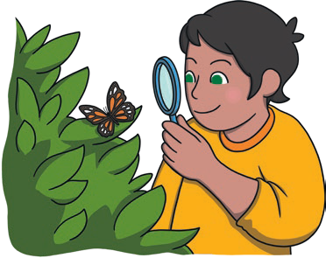

* Look through family photographs and talk about family events and celebrations.
* Talk about how to care for the environment ie recycling
* Plant seeds and water it daily – talk about what it needs to grow.
* Water play – wash toys
* Play with cause-and-effect toys – what happens if we press this button?
* Talk about Chinese New Year and why and how it is celebrated.

**Physical Development**

* Draw a picture of their favourite book character and bring it in for us to see.
* Play with playdough.
* Dances and moves to rhythm of the music.
* Running in the park
* Do an obstacle course indoors / outdoors.
* Encourage your child to dress themselves.
* Encourage hand washing independently.
* X2 daily tooth brushing

Is your child toilet trained? Is he / she ready to be toilet trained? Please talk to us so that we can support you. 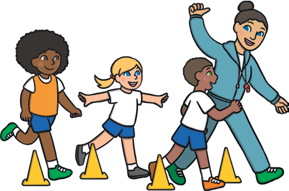

**Expressive art and design**

* Dance with whole body and musical instruments
* Make a musical instrument using different items from home ie tubes, boxes etc
* Create a rhythm with your instrument.
* Roleplay with your child – looking after the baby, café, shops, schools



**Please take some photographs of your child doing these activities and send them to us via EYLOG.**

**Have fun!**